Just Coders



17 November 2021 Mr. Ephraim

PROJECT WEBSITE USER SUPPORT DOCUMENT

**Inside Cover Page**

* **Number of the team**
* DISD313 Group 4, with 3 members
* **Name of the team**
* Just Coders
* **Name and student number of team leader**
* Vusimuzi Mphela 17608576
* **Names and student numbers of team members**
* Given Mnguni 18011644
* Ntandoyenkosi Ndaba 16011865
* **Name and logo of the system**
* The Ben Luc System



Table of Contents

1. Introduction3
2. System requirements…………………………………4
3. How to compile and start shopping……………5
4. Conclusion……………………………………………….17

# Introduction

The document is a guideline of how to compile the Ben Luc system website, the document highlights some of the minimum requirements that the person who wants to interact with the website must meet, the document serves as a guideline on how a customer can interact with the website using the most efficient methods to get maximum performance and efficiency from the website.

When the document is followed accordingly then the website will provide the user/customer with a shopping experience like no other.

# System Requirements

* Please Note that for the website to function/compile or execute efficiently on a computer device, the computer device must have all the requirements defined below, failure to meet the requirements outlined below may result in the website malfunctioning/crashing and giving incorrect/unexpected results.

Hardware resources needed to COMPILE the Ben Luc System WEBSITE

* 5GB of device storage
* Minimum 2.0hz dual core processor
* Minimum 4GB of memory (RAM)
* Minimum 500MB Video dedicated memory (graphic card)
* A computer device

Software resources needed to COMPILE the Ben Luc System WEBSITE

* Wamp Server/Xampp server must be installed on the computer device.
* A computer that has installed a windows operating system.
* Minimum windows 10 Home edition operating system.
* Web browser.

# How to compile and start shopping

* In this section I will be explaining step by step methods of how to compile the Ben Luc system’s website, this guideline will start with were to save the project to compile it successfully and it guide the user until all the different sections of the website are explored.

1. **Step 1 (project location)**

* To successfully compile the project, the project must be stored in the c drive of the computer device that the user/customer will use to compile the website system. The project must be stored inside the Xampp folder, inside the ‘htdocs’ folder.

**Example:**

this is the path where the project can be saved for successful compiling.

C:\xampp\htdocs

1. **Step 2(Xampp server)**

* In this step the user needs to run the xampp program which will enable us to interact with the website using a web browser, please note that if the xampp server has not been installed or running then the user cannot successfully compile the website project.

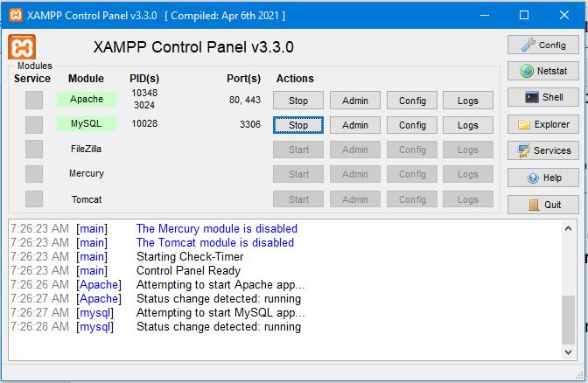

* As you can see in the picture above the xampp server is running/executed, for the user to be able to compile the project on a web browser the ‘Apache’ and ‘MySQL’ modules need to be started as shown in the picture above.

1. **Step 3 (Compiling/executing the project on a web browser)**

* To compile the project first unzip the ‘Ben Luc system website’ folder, in the unzipped folder the are 2 folders which is the ‘Ben Luc Website System’ folder and the ‘BenLucSystemWebsitedb’ folder, the folder that will contain the website source code and executable files is the ‘Ben Luc Website System’ folder. The ‘BenLucSystemWebsitedb’ folder contains files that will help connect the Ben Luc system android application to the system database.
* To compile the website source code and display the Ben Luc system store open a web browser on the computer device and type the following URL in the search area of the website just as shown in the picture below.

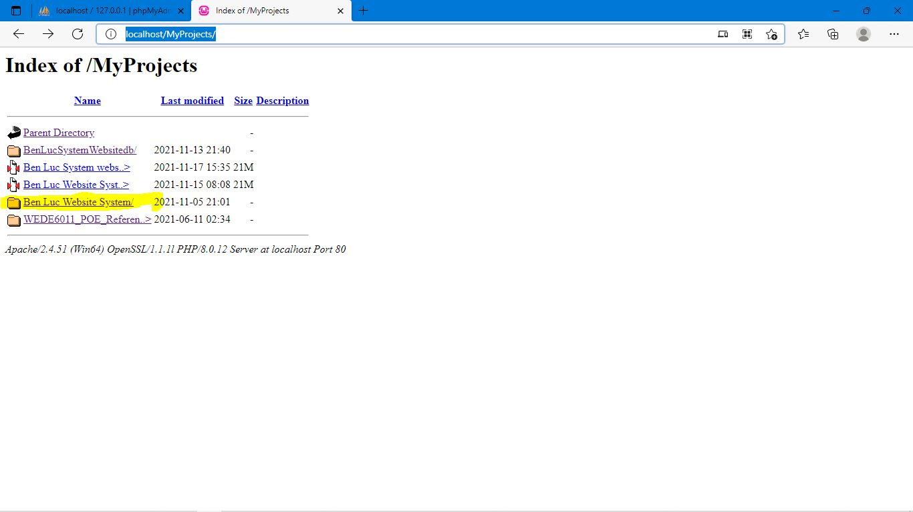

* After typing the URL in the web browser, the page in the above picture should display and you should select the highlighted project. After selecting the highlighted project, the store should display in the web browser just like in the picture below,

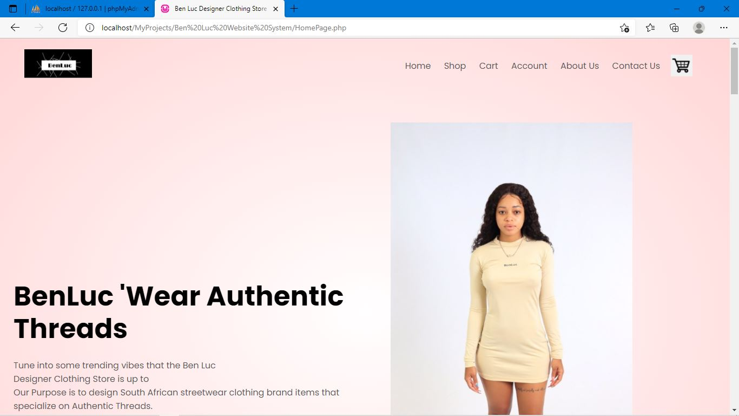

When the project is compiled for the first time the is a popup message that will display click the ok button to remove it from the screen, the popup message display when the are no comments yet in the comment section which is show in the picture below, to get to the comment section the user has to scroll down the website to towards to the footer section to see the website customer comment section.

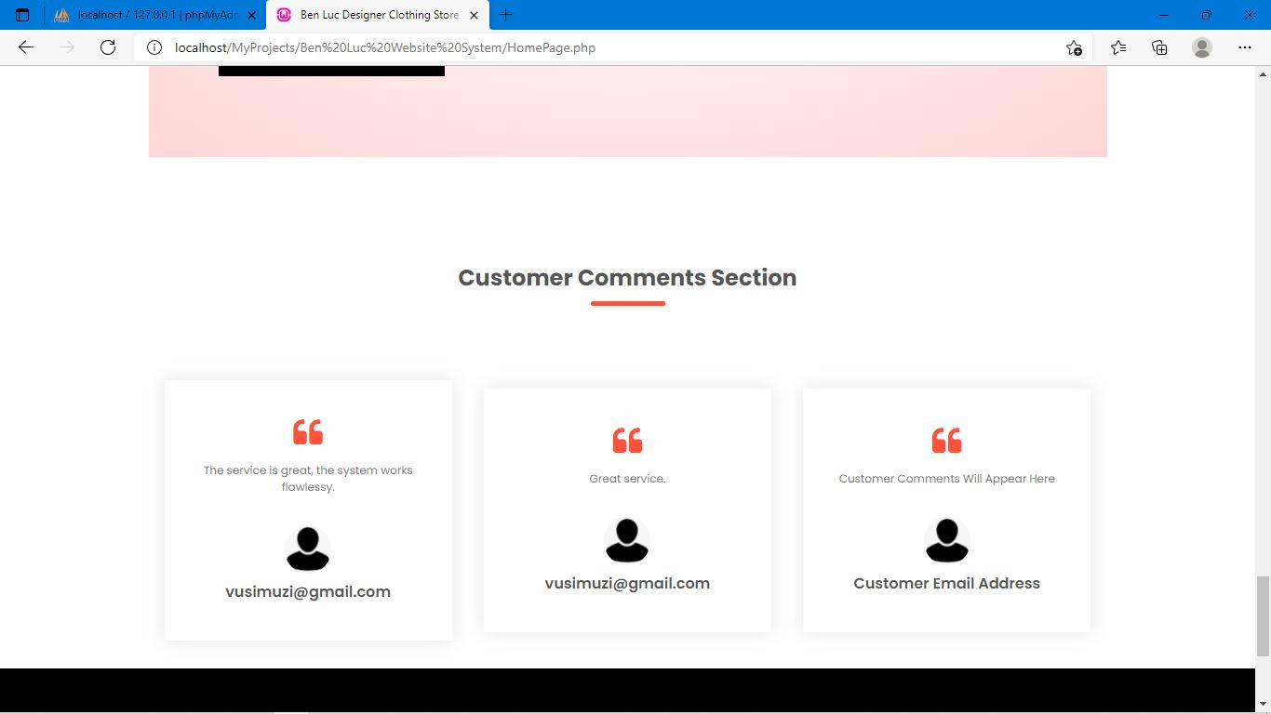

* When the user wants to browse the available clothing categories the user must click the ‘shop’ link in which ever they are currently at, the user can scroll up the page to towards the navigation section of the website or the user can scroll down the website towards the footer section of the website.

After clicking the shop link the user will be directed to the shop page where different categories of clothing item categories appear and there the user can browse clothing items to place the clothing items in the cart. The pictures below demonstrate the shopping experience the user encounters when shopping with the Ben Luc system website.

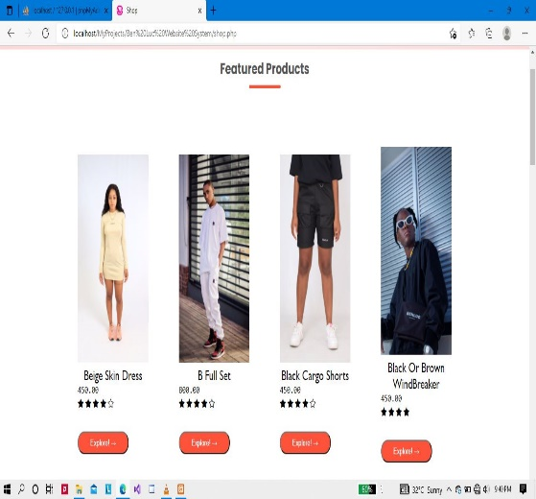 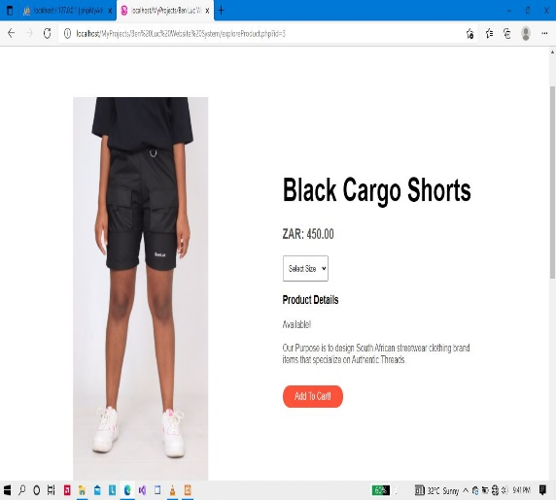

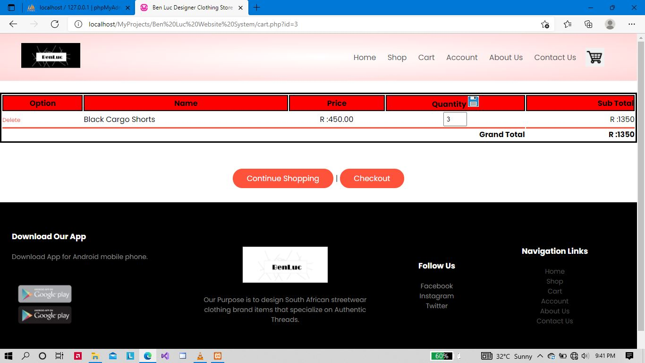

* When the user has successfully placed their favourite clothing items in the cart the user can click the ‘Checkout’ button to place an order of their selected clothing items, if the user has logged in the user will a page which will be give them the option the choose between collecting the purchased clothing items or request a deliver for the purchased items.
* If the user is not logged in yet the user will be re-directed to the login page where they have to login with their registered account credentials or create an account with the Ben Luc system to be able to access its features. The pictures below depict the described scenarios.

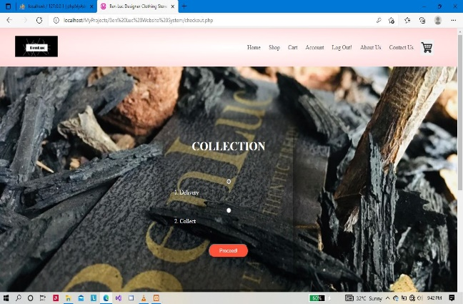 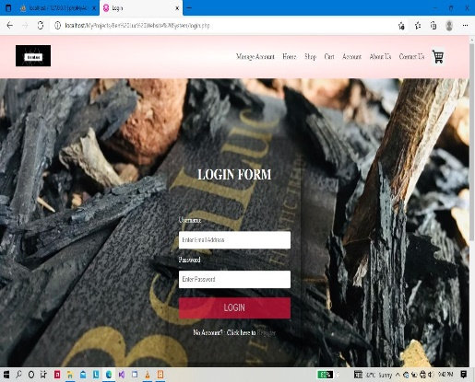

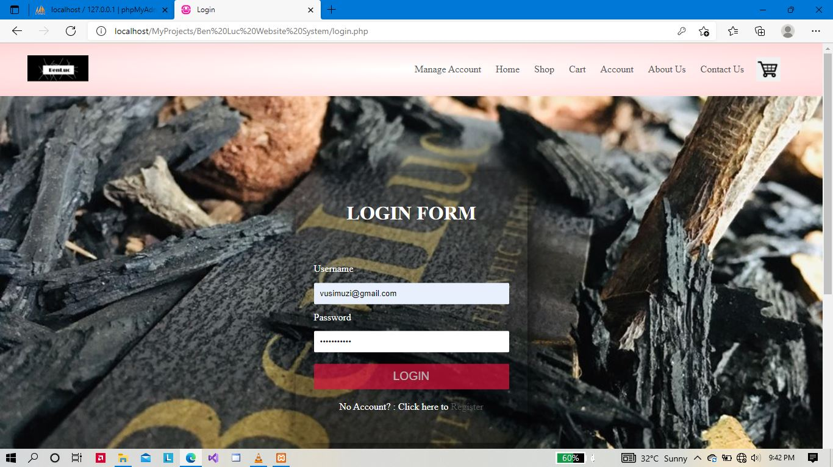

* If the user selected the collect option, then the user will see an order receipt displayed in the web browser, if the user has selected the delivery option, then the user will be directed to a page where they will enter the address of the location, they would like the clothing items to be delivered to. When the user has selected the collect option, after reviewing their order receipt the user has the option to leave a comment about the service, they received from using the website. The pictures below demonstrate this scenario.

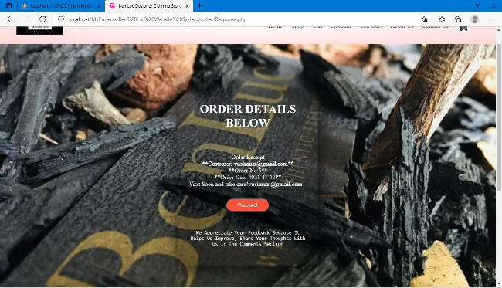 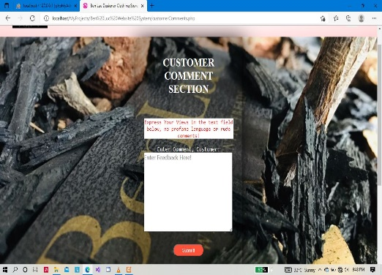

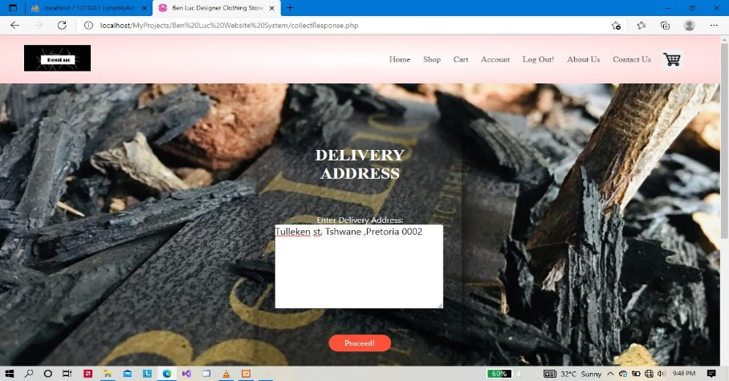

* The user can also review the orders they made and check the progress of their ordered items to either collect them or when can they expect these clothing items to be delivered to their specified location, if the is not logged in then the user will be re-directed to the login page to login first before they can view their order progress status. The pictures below depict the explained scenario.

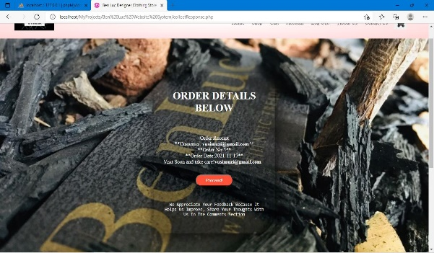 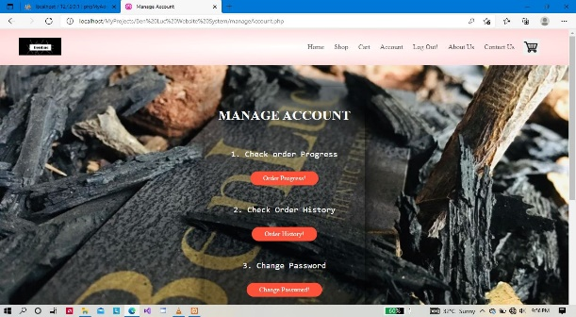

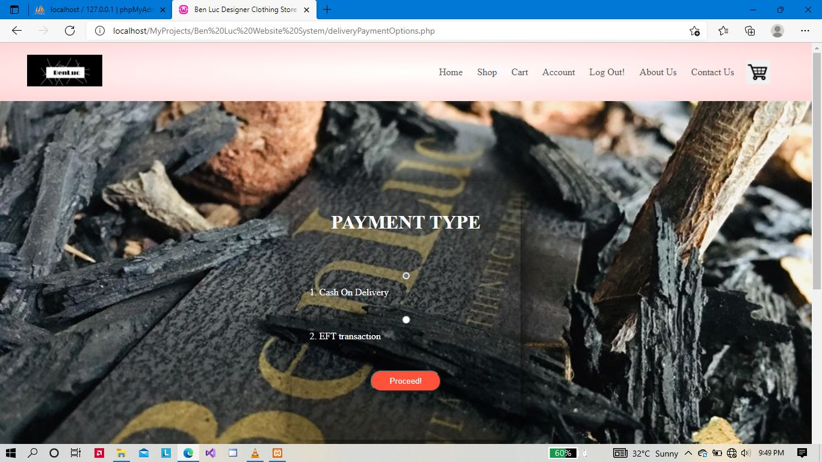

* In the pictures above, the user will be directed to the payment type page after the user clicks the proceed button in the delivery address page, when the user clicks on the manage account link while logged in the manage account will appear as depicted in the pictures above.
* After the user chooses the payment type, they desire the will be directed to a page where they will their receipt and when they click the proceed the button, they will be directed to the customer comment section where they can leave feedback about the shopping experience they received while shopping with the Ben Luc website.

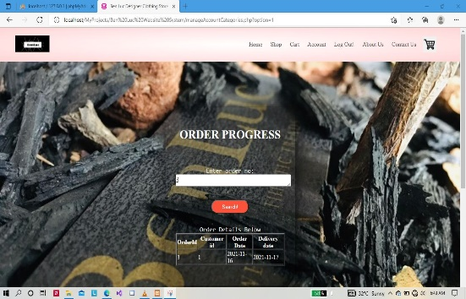 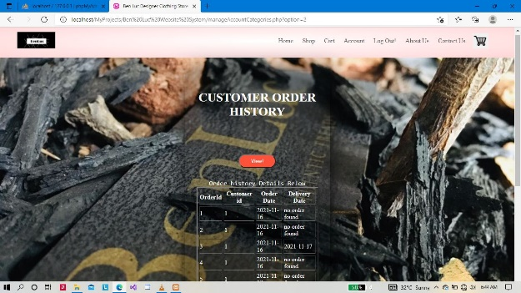

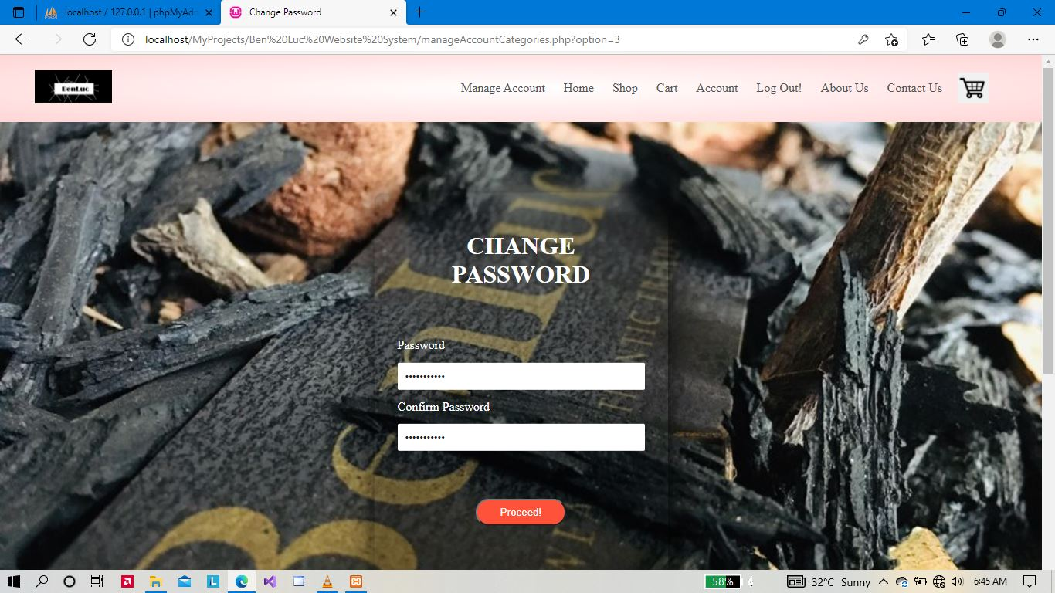

* After the user clicks the manage account link and seeing the manage account page, they can pick the available option whether to change their password, view the order progress and view the history of all the items that have been ordered by the customer since registering an account with the ben Luc system website.
* Each of the options in the manage account page will lead to the sections that are depicted in the pictures above, the user must enter the order number they received when making a purchase, if the user has forgotten their order number, they can retrieve it in the customer order history page which is still in the manage account page as depicted by the pictures above.
* The pictures below depict the functionality that the user can interact with like login, registration, viewing the about us page and interacting with the contact us page of the ben Luc system website.

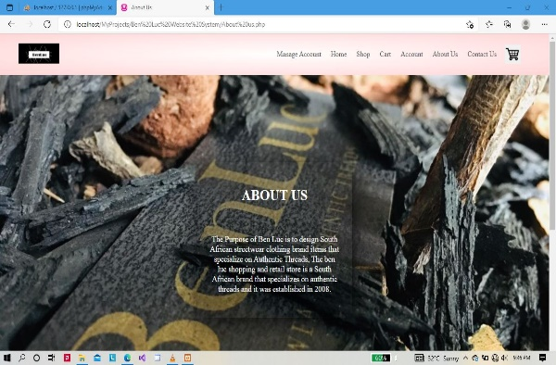 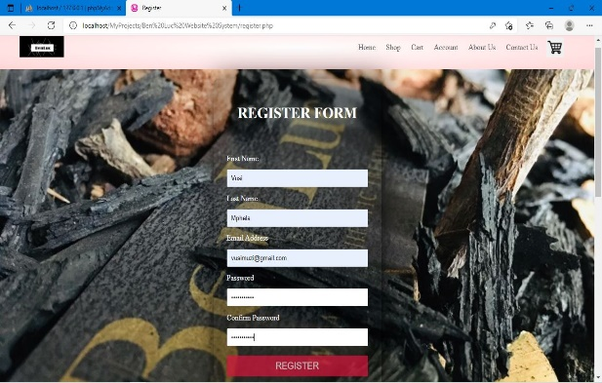

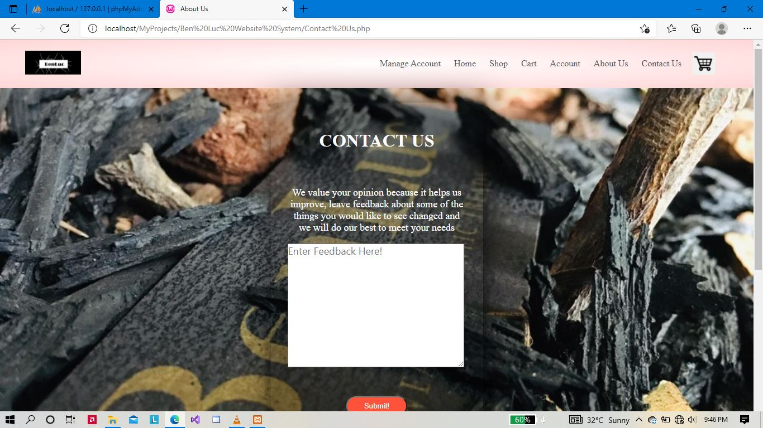

* The Ben Luc system website has been developed to be maintainable, the admin or the Ben Luc store operational manager can manage the website from the admin page, to get to the admin page the admin has to login with the admin credentials that are stored in the database.
* The ben Luc system website has been developed to allow administrators to change passwords only and not create many manager accounts for security issues. The pictures below depict the manager logging in and interacting with the features that the manager/administrator entails.

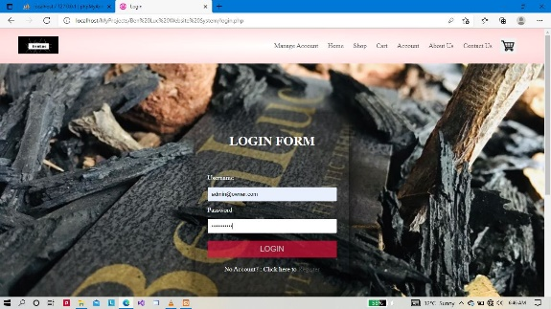 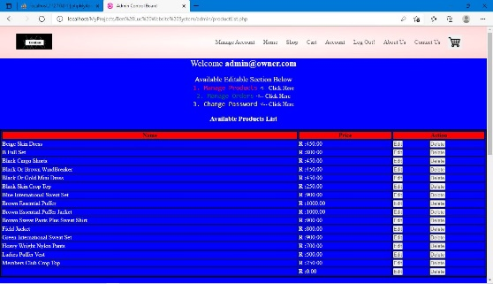

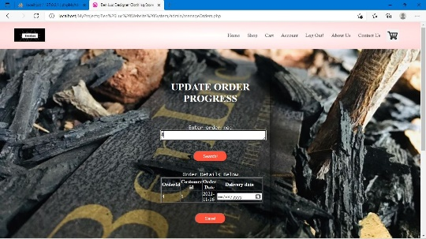 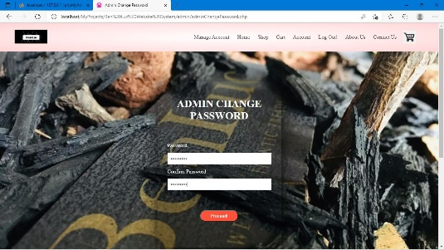

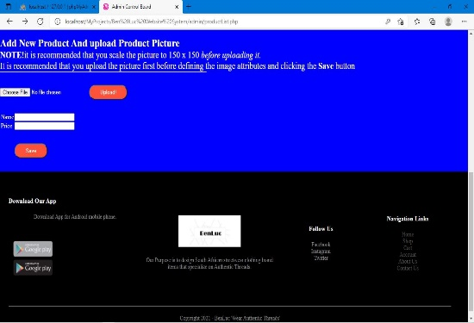 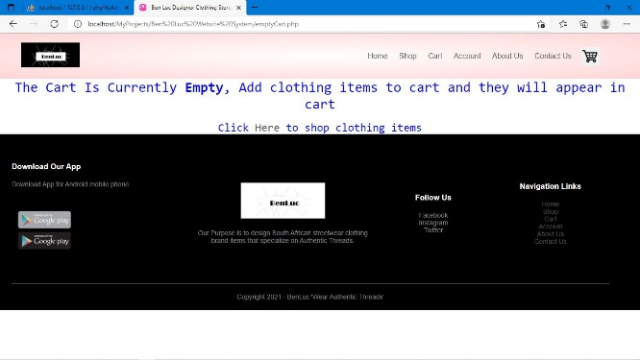

* In the pictures above the administrator can perform different manager functions as depicted in the pictures above, if the website is loaded for the first time in the user computer device, then there are no administrator credentials that will allow the user to login and manage the website.
* Add these credentials by following the steps outlined below.

**Step 1 (accessing the system database)**



* Access the Xampp executable program graphical user interface and click on the admin button highlighted with the green highlighter, ensure that the ‘admin’ button that is clicked is the one that is aligned with the MySQL module in the Xampp graphical user interface as depicted by the picture above.
* After clicking this button, a web browser will open, and the user will be directed to the system database section. In the system database section, the user must select the database table ‘tbladmin’ just as depicted in the picture below.

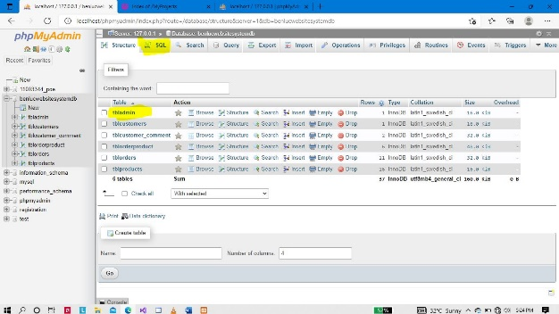

* The user must click the highlighted ‘SQL’ section in the webpage and in this page the user will have to insert login credentials data into the database table ‘tbladmin’, step 2 elaborates this process.

**Step 2(adding admin login credentials into the database)**

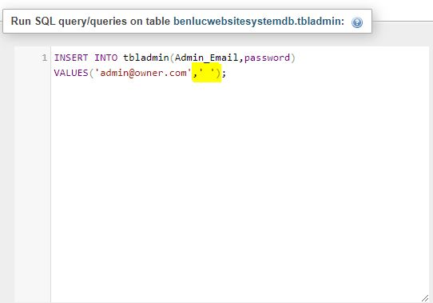

* The highlighted area is where the user must add the password that they will use to login into the website login page and the email address to access the manager/administrator page of the website.
* Before the user insert a password into the database table ‘tbladmin’ the password must meet the following requirements, the Password Must contain at least one number and one uppercase and lowercase letter, and at least 8 or more characters.
* The email address that is inserted into the database table ‘tbladmin’ email address must meet the following requirements, The email address must contain letters (lowercase only), maybe numbers in the format: [characters@characters.domain](mailto:characters@characters.domain)
* The user must get an md5 encryption of their password before inserting the password into the database table, visit an online md5 encryption website to encrypt the admin password following the specified password minimum requirements above.

# Conclusion

This document was correct at the time it was compiled, if the user of the systems follows the guidelines identified above then the user should have a smooth experience using the website. The information in this document was written by the developer of the website, should any errors or confusion arise contact Vusimuzi Mphela of the group 4 team.